Mack M3 Assignment: Diverse Groups/ LGQBT

Diverse Groups Literature Lists
Stonewall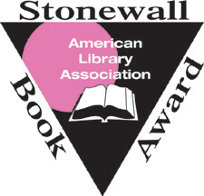Honored since 1971, this award goes to the best authored book for lesbigay books and is sponsored by the ALA Round Table. 48 books have garnered this award. They are given in two categories - Stonewall Book Award-Barbara Gittings Literature Award and the Stonewall Book Award-Israel Fishman Non-Fic   Often referred to as the Lammy’s, this award is given to the books identified as lesbian, transgender, bisexual and gay and the best in their category. Given for over 30 years.   A group of member authors that are interested in supporting those that are LGBTQ , gifting awards for the best books in LGBTG. Randy Shilts – was a reporter for The Advocate and now has books awarded in his name. | Resource 1  Book Awards for
THE CENTER  – The heart of New York City’s community support for LGBQT programs.  Advancing the Human Rights and Inclusion of LGBTI People  A Resource Platform for Parliamentarians – a joint publication alongside the United Nations Development Program to ensure no person is left behind in the advocating of human rights for equality.  https://www.pgaction.org/inclusion/   A youth led organization to protect the sexual rights of youth https://www.choiceforyouth.org/our-work/international-advocacy/?gclid=EAIaIQobChMIqM_p76e84QIVBYrICh1OrAhcEAAYAyAAEgJ43fD_BwE  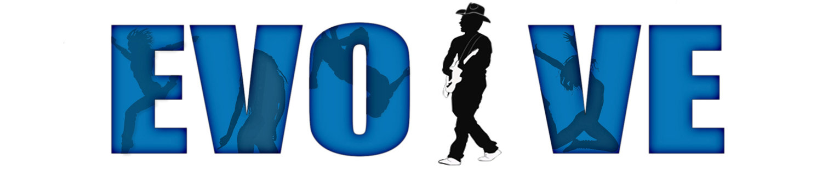The Evolve Project - is a project offering workshop opportunities and consultation for youth and parents to empower with resources that support LGBT | Resource 2 – Org. and Organizations and Resources for Diverse Youth
Sara Farizan – author of If You Could Be Mine and ‘Tell Me Again How a Crush Should Feel- a look at homosexuality from another country’s perspective as it is illegal in Iran, and the two girls in this twisted tale of fate are torn by the laws of their country.  Jacqueline Woodson - From the Notebooks of Melanin Sun – one of the many first looks at LGBTQ literature from the child’s perspective of a parent coming out  David Leviathan - author of several books but Boy Meets Boy springs the reader into the ultimate perfectly accepting world.  Jandy Nelson - Winner of a Stonewall Book Award for, ‘I’ll Give You the Sun’,  Gabby Rivera – author of, ‘Juliet Nelson Takes a Breath’, about a lesbian of color (Puerto Rican) coming out to her mother  Becky Albertali & Adam Silvera – Authors of What If It’s Us?  Nina La Cour - Author of the story, ‘We Are Okay’ -  Mariko Tamaki & Jillian Tamaki- NY Times Best selling authors and Printz Award winners, of the book, ‘This one Summer ‘ | Resourse 3  Key Diverse Authors and Illustrators
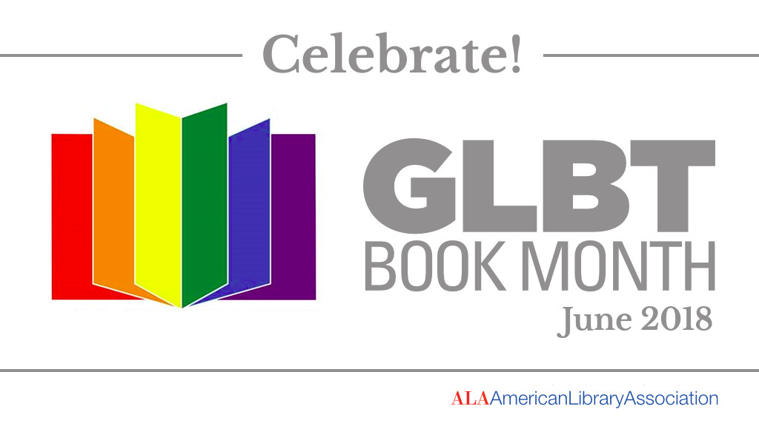 An annual event, occurring in June, initiated by the ALA but coordinated by several other outreach groups.  Planet Romeo Foundation – is an independent organization created to support the focus on achieving societal change to improve communities for people that are LGBTI https://www.planetromeofoundation.org/?gclid=EAIaIQobChMIv_WduaW84QIVEp-fCh3j4w0IEAAYAyAAEgKioPD_BwE  The Guardian - a blog discussing why awards are needed to support the LGBQT authors and books.  https://www.theguardian.com/books/booksblog/2013/nov/06/lgbt-book-green-carnation-award  YA Pride - a website and blog dedicated to everything LGBTQIA+ in YA!” They were started in 2011 by creator and all around amazing human Vee (who also contributed to this site!) with a mission to, “to mobilize a clear and active market for LGBTQIA+ YA”  http://www.yapride.org | Resource 4  Blogs and other resources

